**Exploration of German Credit Dataset using WEKA**

1. List of attribute names and their types :

* Checking_status - nominal
* Duration - numeric
* Credit_history - nominal
* Purpose - nominal
* Credit_amount - numeric
* Saving_status - nominal
* Employment - nominal
* Installement_commitment - numeric
* Personal_status - nominal
* Other_parties - nominal
* Residence_since - numeric
* Property_magnitude - nominal
* Age - numeric
* Other_payment_plan - nominal
* Housing - nominal
* Existing_credits - numeric
* Job - nominal
* Num_dependents - numeric
* Own_telephone - nominal
* Foreign_worker - nominal
* Class - nominal

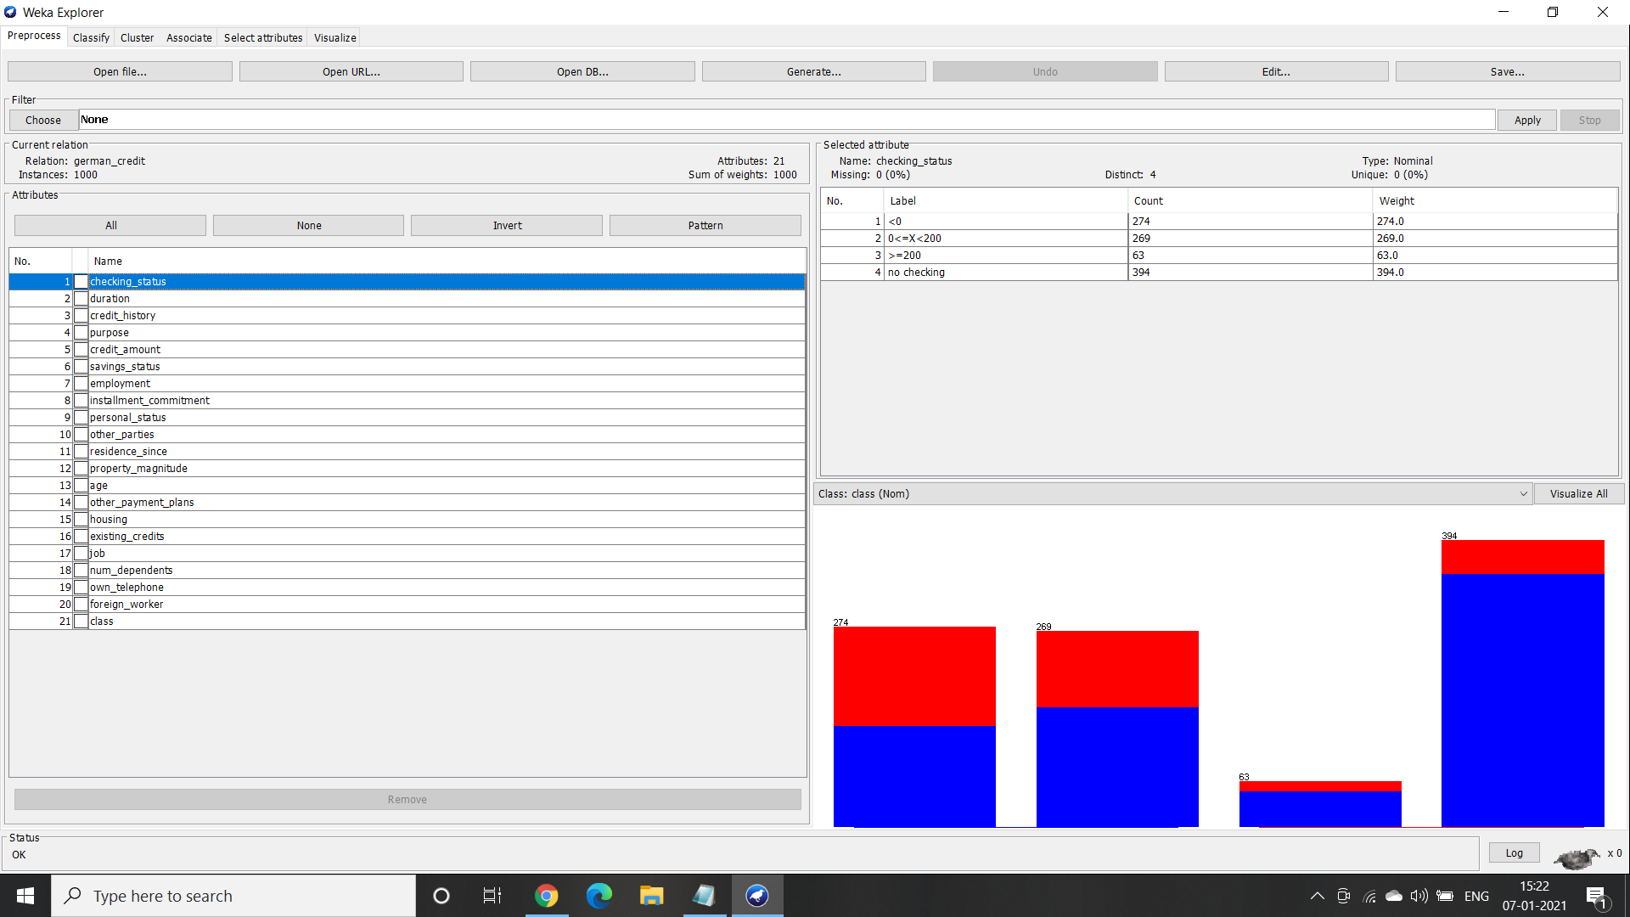

1. Number of records in each dataset :

The german credit dataset has 21 features with a total 1000 entries.

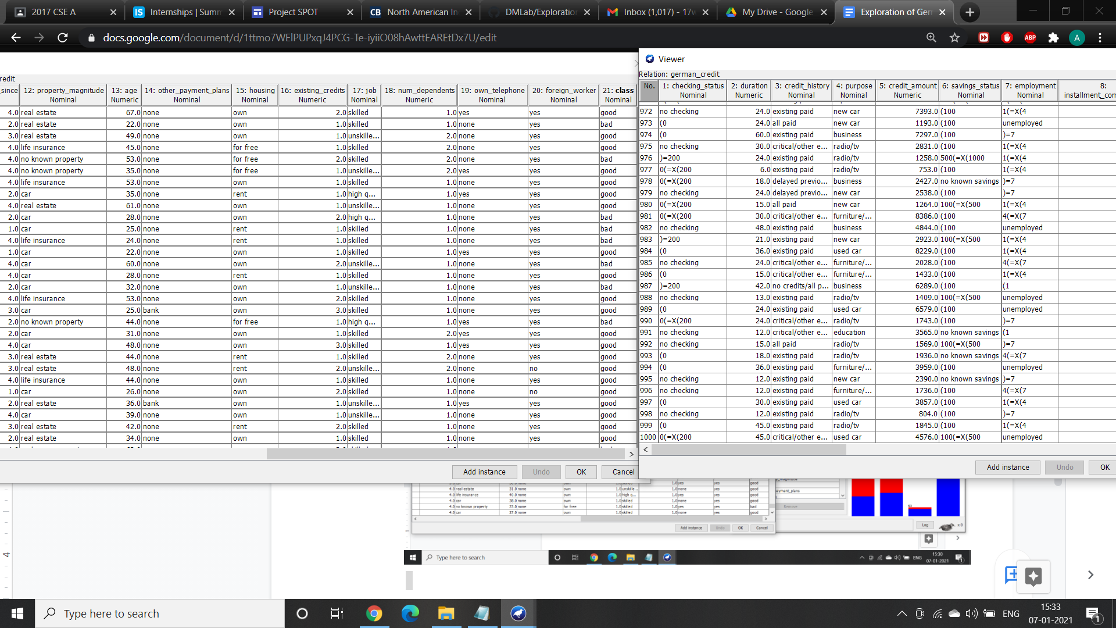

1. Histogram :

In the below picture all the attributes of the dataset are visually represented.

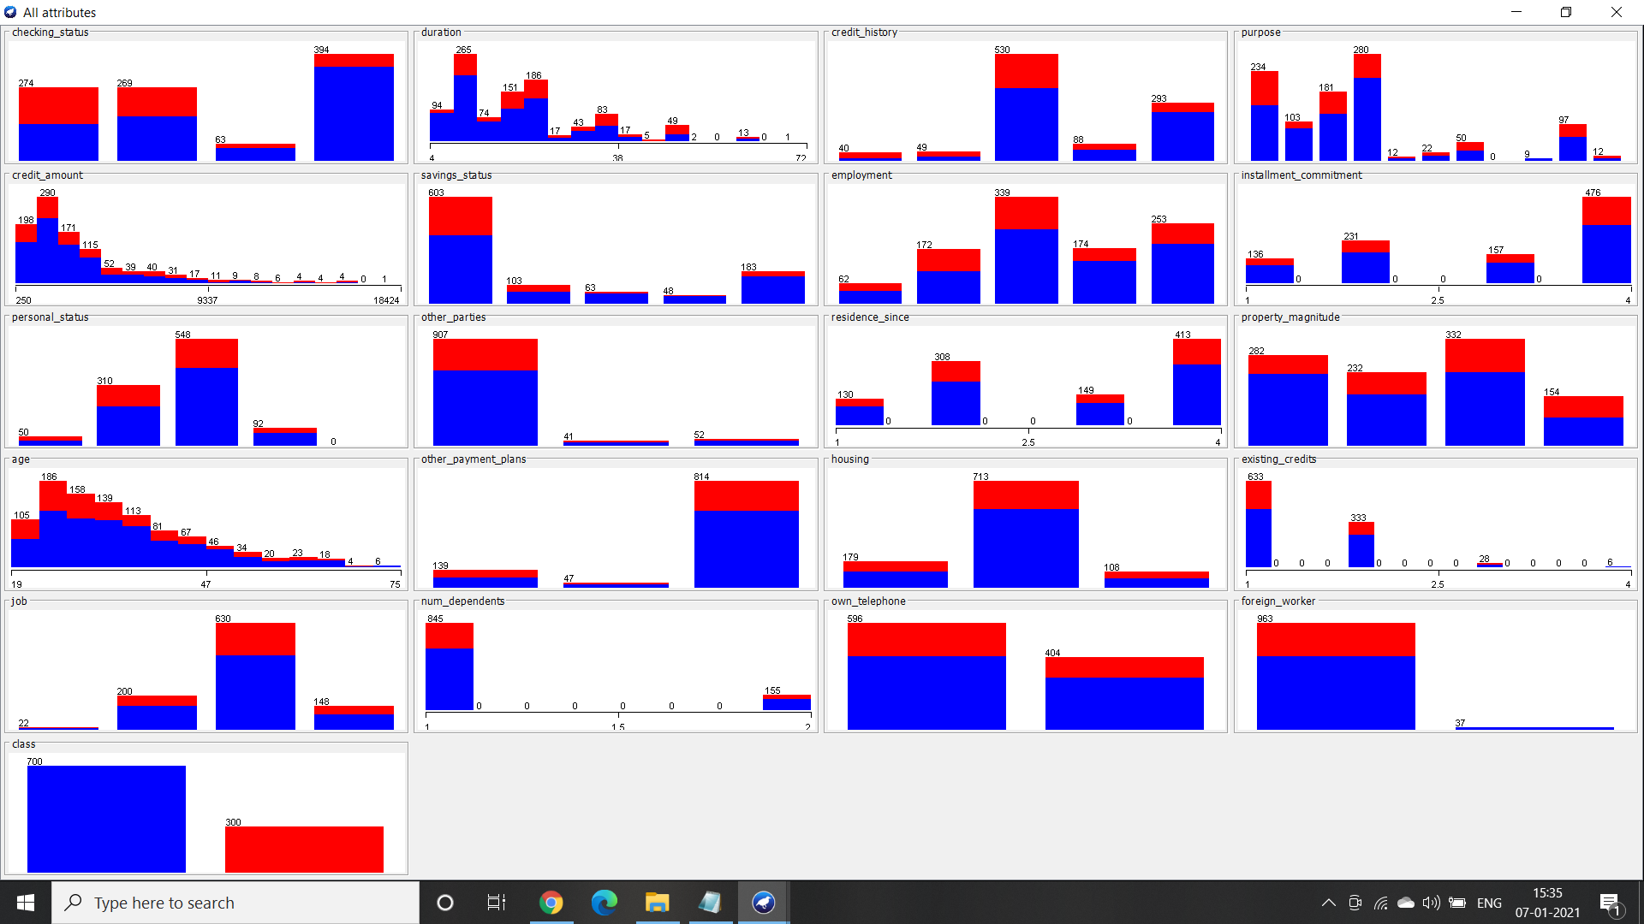

1. Determining the number of records in each class :

There are total two distinct classes in this dataset that is good and bad

Total number of records for good = 700

Total number of records for bad = 300

